Practical no. 26
Name :- Danish Altaf Solkar Enrolment no. :-24111590805
Class :- CO3K – B Subject :- DMS
Aim:- Implement Triggers for given database

Program :-
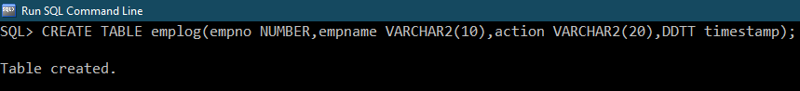

Program :-
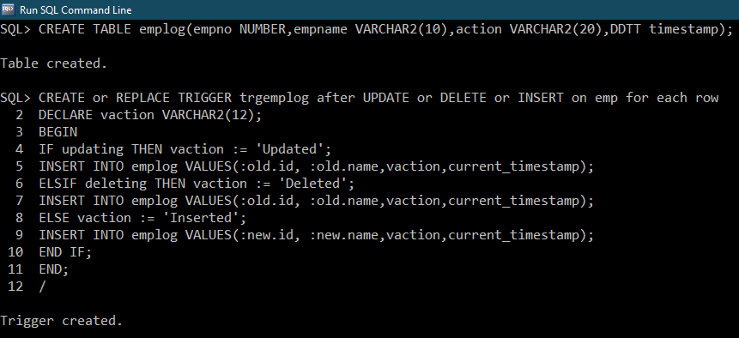

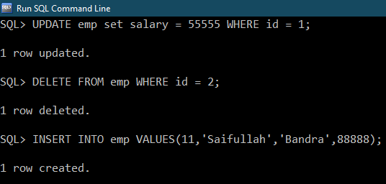

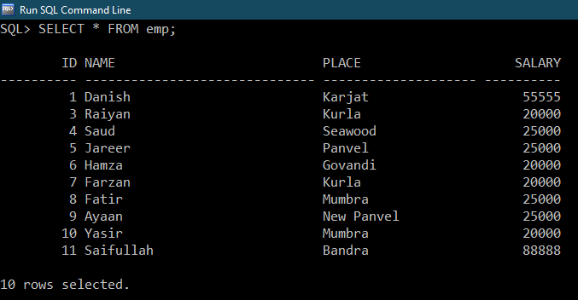

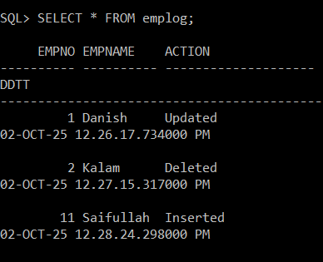

Exercise :-
Program :-
1) 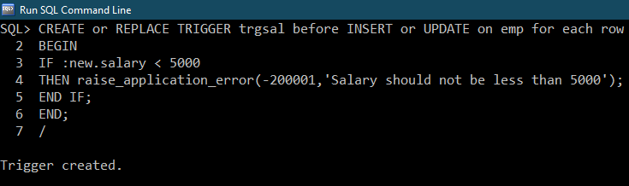
2)
